Ryan Richardson

CS510

HW9

1. I had some trouble getting the contour lines to appear properly for the original, so I’ve attached 2 potential graphs.   
   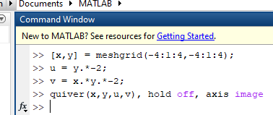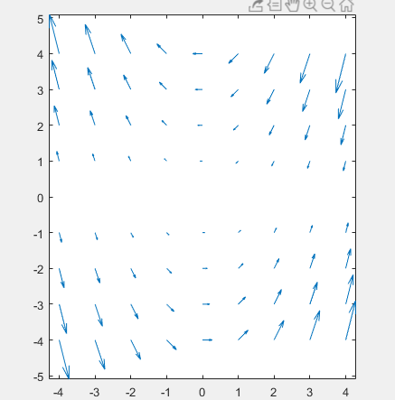 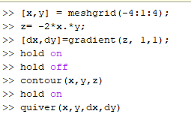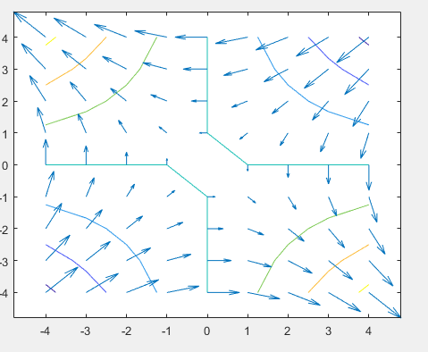
2. The max step size for y’ = -50y is the following
   1. RK 3rd Order = |50h| <= 1, so h <= 0.02
   2. Adams-Bashforth
   3. Adams-Moulton
   4. Stiffly Stable
3. Vanderpol Comparisons. Using a stiff solver vs a regular ode solver is going to be highly dependent on the type of solver used, as demonstrated in the examples.
   1. ODE23 - 2.1332 seconds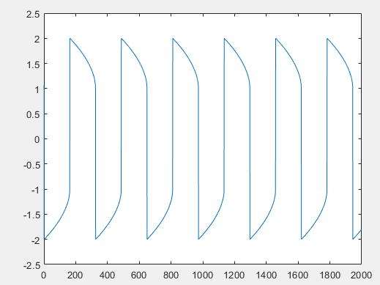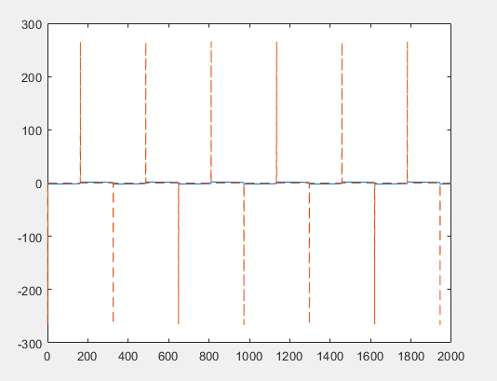
   2. ODE45 – 7.0855 seconds 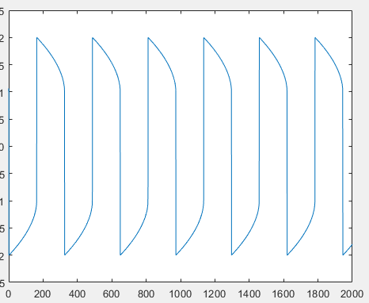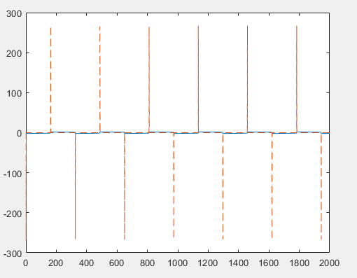
   3. ODE15 - .4584 seconds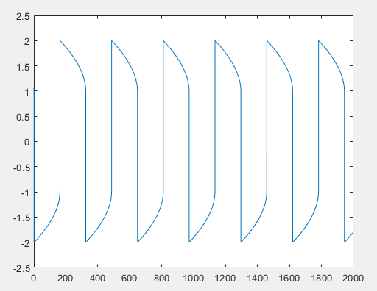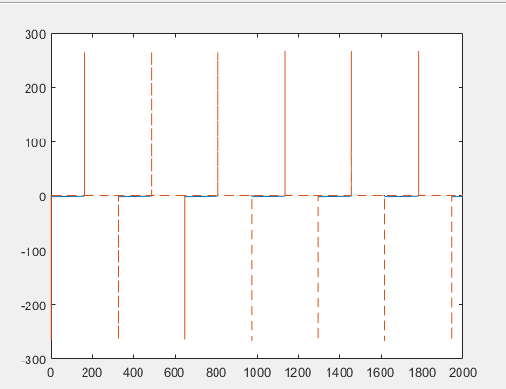
4. Based on the time elapsed, the performance of the existing ODE solvers vary greatly. In this case, ODE45 was 35 times slower than ODE15s. The tested versions of the ODE solver all returned the same values, with a similar graph.The numerical analysis shows each rate at which the reaction will be performed with respect to the input c (graph below). 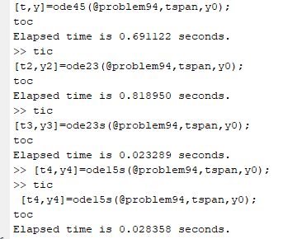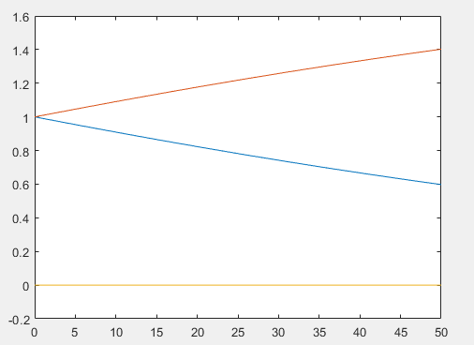
5. 